B.Tech. III Year I Semester Syllabus
UI DESIGN - FLUTTER
LIST OF EXPERIMENTS
Write a Program to implement the following using Python.
1. a) Install Flutter And Dart SDK
b) Write a simple Dart program to understand the language basics.
2. a) Explore various flutter widgets (Text,Image,Container,etc..
) b) Implement different layout structures using Row,Column,and Stack widgets
3. a) Setup navigation between different screens using navigator
b) Implement navigation with named routes
4. a) Learn about stateful and stateless widgets
5. a) Create custom widgets for specific UI elements
6. a) Design a form with various input fields
b) Implement form validation and error handling
7. a) Add animations to UI elements using flutter's animation framework
b) Experiment with different types of animations like fade,slide,etc.
8. Display the fetched data in a meaningful way in the UI
9) Use Flutter’s debugging tools to identify and fix issues.

INTRDUCTION FLUTTER
Flutter is an open-source UI framework created by Google for building applications from a single codebase.
With Flutter, you can write code once (using the Dart programming language) and create apps for:
- Android
- iOS
- Web
- Windows
- macOS
- Linux

How Flutter fits with Dart
- Dart = the programming language.
- Flutter = the framework that provides UI widgets, navigation, animations, and other tools for building apps.
Think of it like:
- English = language
- Microsoft Word = tool built around that language
Similarly:
- Dart = language
- Flutter = app-development framework using Dart

Simple Flutter Example
import 'package:flutter/material.dart';
void main() {
runApp(
MaterialApp(
home: Scaffold(
appBar: AppBar(title: Text('My App')),
body: Center(
child: Text('Hello Flutter!'),
),
),
),
);
}

Why developers use Flutter
- One codebase for multiple platforms.
- Fast development with Hot Reload (see UI changes instantly).
- Rich set of built-in UI widgets.
- Good performance because Dart code is compiled to native code.

Flutter vs Dart vs DartPad
Technology | Purpose
DartPad | Online editor to write and run Dart/Flutter examples
Dart | Programming language
Flutter | Framework for building apps with Dart
If you're just starting, a common learning path is:
- Learn basic Dart syntax.
- Learn Flutter widgets (Text, Container, Row, Column, etc.).
- Build simple Flutter apps.
- Learn state management and app architecture.

- a) Install Flutter And Dart SDK.
To install Flutter and the Dart SDK, you can follow these steps:
- Download Flutter: Visit the Flutter website's Get Started page and download the Flutter SDK for your operating system (Windows, macOS, or Linux).
- Extract the Flutter SDK:
After downloading, extract the contents of the compressed file to a location on your computer where you want to store the Flutter SDK. For example, you can extract it to C:\flutter on Windows, /Users//flutter on macOS, or ~/flutter on Linux.
c) Add Flutter to your PATH: Update your system's PATH variable to include the Flutter bin directory. This step allows you to execute Flutter commands from any directory in your terminal or command prompt. The precise steps for updating the PATH vary depending on your operating system.
Windows:
From the Start search bar, type 'env' and select 'Edit the system environment variables'. Click on 'Environment Variables'. Under 'System Variables', find the 'Path' variable, select it, and click 'Edit'. Click 'New' and add the path to the bin directory inside the Flutter directory (e.g., C:\flutter\bin). Click 'OK' on all open dialogs to save your changes.
macOS and Linux:
Open a terminal window. Run the following command to open the profile file associated with your terminal (.bash_profile, .bashrc, .zshrc, or similar): nano ~/.bash_profile Add the following line at the end of the file: export PATH="$PATH:/path/to/flutter/bin" Press Ctrl + X to exit, then Y to save changes, and Enter to confirm.
d) Verify the Flutter installation:
Open a new terminal window, and run the following command to verify that Flutter is properly installed: flutter --version This command should display the Flutter version and other relevant information if the installation was successful.
e) Install Flutter dependencies:
Depending on your development environment, you may need to install additional dependencies, such as Android Studio to fully set up your Flutter development environment.
f) Download Dart SDK
(if not bundled with Flutter): Flutter comes with the Dart SDK bundled, so if you've installed Flutter, you should have the Dart SDK as well. However, if you need to install Dart separately, you can download it from the Dart "SDK archive".
- Write a simple Dart program to understand the language basics.
import 'package:flutter/widgets.dart';
void main() =>
runApp(
const Center(
child:
Text('hello world',
textDirection:TextDirection.ltr,
),
),
);
Output:
Hello world

Week 2
- a) Explore various Flutter widgets (Text, Image, Container, etc.).
Text Widget:

import 'package:flutter/material.dart';
// function to trigger build process
void main() => runApp(const TestTextClass());
class TestTextClass extends StatelessWidget {
const TestTextClass({Key? key}) : super(key: key);
@override
Widget build(BuildContext context) {
return MaterialApp(
home: Scaffold(
backgroundColor: Colors.lightGreen,
appBar: AppBar(
backgroundColor: Colors.blue,
title: const Text("Text Widget"),
), // AppBar
body: Center(
child: Column(

mainAxisAlignment: MainAxisAlignment.center,
children: <Widget>[
const Text(
'Hello Students',
style: TextStyle(fontWeight: FontWeight.bold),
),
const Text(
"Welcome to Flutter Lab",
style: TextStyle(fontStyle: FontStyle.italic),
),
],
) ,

),
),// Scaffold
);// MaterialApp
}
}

Output:

Text Widget
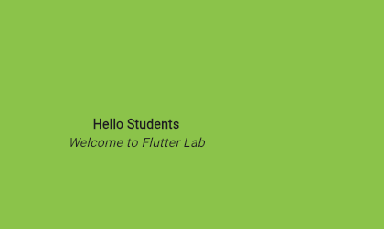

Container Widget:
import 'package:flutter/material.dart';
void main() => runApp(const MyApp());
class MyApp extends StatelessWidget {
const MyApp({Key? key}) : super(key: key);
@override
Widget build(BuildContext context) {
return MaterialApp(
home: Scaffold(
appBar: AppBar(
title: const Text("Container Example"),
),
body: Container(
height: 200,
width: double.infinity,
//color: Colors.purple,
alignment: Alignment.center,
margin: const EdgeInsets.all(20),
padding: const EdgeInsets.all(30),
decoration: BoxDecoration(
border: Border.all(color: Colors.black, width: 3),
),
child: const Text("Hello! i am inside a container!",
style: TextStyle(fontSize: 20)),
),
),
);
}
}

Output:
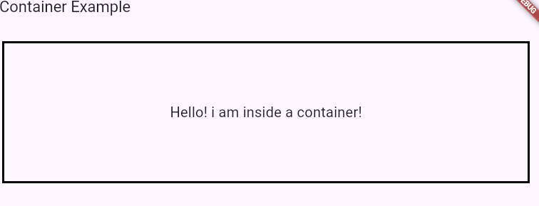

b).Implement different layout structures using Row, Column, and Stack widgets
Row:
import 'package:flutter/material.dart';
void main() { runApp(MyApp()); }
class MyApp extends StatelessWidget {
@override
Widget build(BuildContext context) {
return MaterialApp(
home: MyHomePage()
);
}
}
class MyHomePage extends StatefulWidget {
@override
_MyHomePageState createState() => _MyHomePageState();
}
class _MyHomePageState extends State<MyHomePage> {
@override
Widget build(BuildContext context) {
return Scaffold(
appBar: AppBar(
title: Text("Flutter Row Example"),
),
body: Row(
mainAxisAlignment: MainAxisAlignment.spaceEvenly,
children:<Widget>[
Container(
margin: EdgeInsets.all(12.0),
padding: EdgeInsets.all(8.0),
decoration:BoxDecoration(
borderRadius:BorderRadius.circular(8),
color:Colors.green
),
child:
Text("Vaagdevi",style:
TextStyle(color:Colors.yellowAccent,fontSize:25),),
),
Container(
margin: EdgeInsets.all(15.0),
padding: EdgeInsets.all(8.0),
decoration:BoxDecoration(
borderRadius:BorderRadius.circular(8),
color:Colors.green
),
child: Text("Engineering",style:
TextStyle(color:Colors.yellowAccent,fontSize:25),),
),
Container(
margin: EdgeInsets.all(12.0),
padding: EdgeInsets.all(8.0),
decoration:BoxDecoration(
borderRadius:BorderRadius.circular(8),
color:Colors.green
),
child: Text("College",style:
TextStyle(color:Colors.yellowAccent,fontSize:25),),
)
]
),
);
}
}

Output:
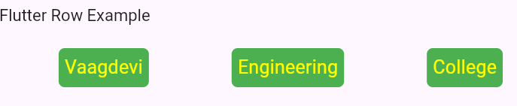
Column:
import 'package:flutter/material.dart';
void main() { runApp(MyApp()); }
class MyApp extends StatelessWidget {
@override
Widget build(BuildContext context) {
return MaterialApp(
home: MyHomePage()
);
}
}
class MyHomePage extends StatefulWidget {
@override
_MyHomePageState createState() => _MyHomePageState();
}
class _MyHomePageState extends State<MyHomePage> {
@override
Widget build(BuildContext context) {
return Scaffold(
appBar: AppBar(
title: Text("Flutter Column Example"),
),
body: Column(
mainAxisAlignment: MainAxisAlignment.spaceEvenly,
children:<Widget>[
Container(
margin: EdgeInsets.all(12.0),
padding: EdgeInsets.all(8.0),
decoration:BoxDecoration(
borderRadius:BorderRadius.circular(8),
color:Colors.green
),
child:
Text("Vaagdevi",style:
TextStyle(color:Colors.yellowAccent,fontSize:25),),
),
Container(
margin: EdgeInsets.all(15.0),
padding: EdgeInsets.all(8.0),
decoration:BoxDecoration(
borderRadius:BorderRadius.circular(8),
color:Colors.green
),
child: Text("Engineering",style:
TextStyle(color:Colors.yellowAccent,fontSize:25),),
),
Container(
margin: EdgeInsets.all(12.0),
padding: EdgeInsets.all(8.0),
decoration:BoxDecoration(
borderRadius:BorderRadius.circular(8),
color:Colors.green
),
child: Text("College",style:
TextStyle(color:Colors.yellowAccent,fontSize:25),),
)
]
),
);
}
}

Output:
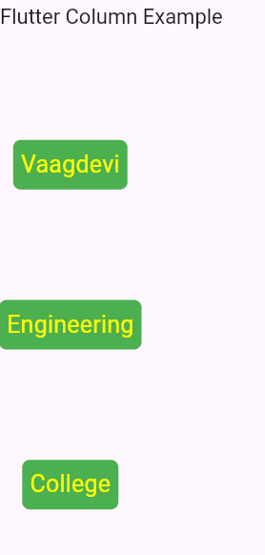

Stack:
import 'package:flutter/material.dart';
void main() { runApp(MyApp()); }
class MyApp extends StatelessWidget {
@override
Widget build(BuildContext context) {
return MaterialApp(
home: MyHomePage()
);
}
}
class MyHomePage extends StatefulWidget {
@override
_MyHomePageState createState() => _MyHomePageState();
}
class _MyHomePageState extends State<MyHomePage> {
@override
Widget build(BuildContext context) {
return Scaffold(
appBar: AppBar(
title: Text("Flutter Stack Example"),
),
body:
Stack(
alignment: const Alignment(0.6, 0.6),
children: [
const CircleAvatar(
backgroundImage: AssetImage('images/vec.jpg'),
radius: 100,
),
Container(
decoration: const BoxDecoration(
color: Colors.black45,
),
child: const Text(
'CSE',
style: TextStyle(
fontSize: 20,
fontWeight: FontWeight.bold,
color: Colors.white,
),
),
),
],
),
);
}
}

Output:

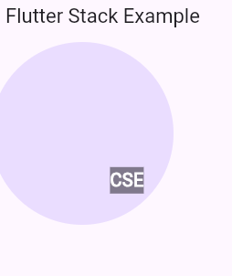

Week-3
- a) Setup navigation between different screens using navigator.
import 'package:flutter/material.dart';

void main() {
runApp(const MaterialApp(
title: 'Navigation Basics',
home: FirstRoute(),

));
}

class FirstRoute extends StatelessWidget {

const FirstRoute({super.key});

// This widget is the root of your application.
@override
Widget build(BuildContext context) {
return Scaffold(
appBar: AppBar(
title: const Text('First Route'),
),

body: Center(

child: ElevatedButton(
child: const Text('open route 1'),
onPressed: () {
Navigator.push(
context,
MaterialPageRoute(builder: (context) => const SecondRoute()),
);
},
),
),
);
}
}

class SecondRoute extends StatelessWidget {
const SecondRoute({super.key});

@override
Widget build(BuildContext context) {
return Scaffold(
appBar: AppBar(
title: const Text('Second Screen'),
),
body: Center(
child: ElevatedButton(
onPressed: () {
// Navigate back to first screen when tapped.
},
child: const Text('Go back!'),
),
),
);
}
}
Output:
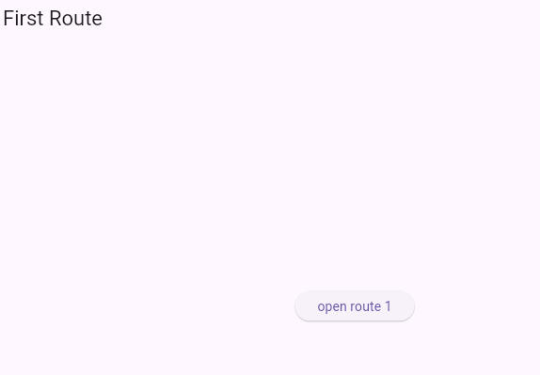
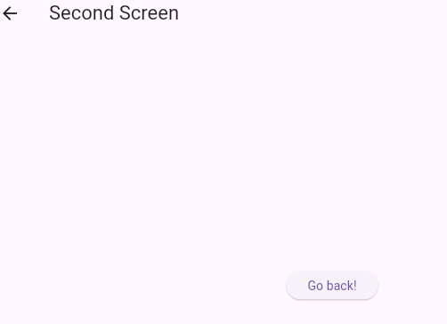

b).Implement navigation with named routes
import 'package:flutter/material.dart';

void main() {
runApp(
MaterialApp(
title: 'Named Routes Demo',
// Start the app with the "/" named route. In this case, the app starts
// on the FirstScreen widget.
initialRoute: '/',
routes: {
// When navigating to the "/" route, build the FirstScreen widget.
'/': (context) => const FirstScreen(),
// When navigating to the "/second" route, build the SecondScreen widget.
'/second': (context) => const SecondScreen(),
},
),
);
}

class FirstScreen extends StatelessWidget {
const FirstScreen({super.key});

@override
Widget build(BuildContext context) {
return Scaffold(
appBar: AppBar(
title: const Text('First Screen'),
),
body: Center(
child: ElevatedButton(
// Within the `FirstScreen` widget
onPressed: () {
// Navigate to the second screen using a named route.
Navigator.pushNamed(context, '/second');
},
child: const Text('Launch screen'),
),
),
);
}
}

class SecondScreen extends StatelessWidget {
const SecondScreen({super.key});

@override
Widget build(BuildContext context) {
return Scaffold(
appBar: AppBar(
title: const Text('Second Screen'),
),
body: Center(
child: ElevatedButton(
// Within the SecondScreen widget
onPressed: () {
// Navigate back to the first screen by popping the current route
// off the stack.
Navigator.pop(context);
},
child: const Text('Go back!'),
),
),
);
}
}
Output:
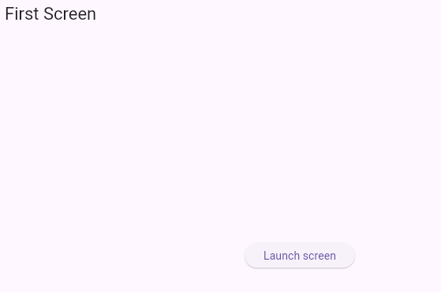
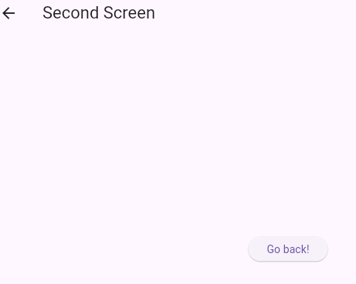

- a) Learn about stateful and stateless widgets.
StatefulWidget.
import 'package:flutter/material.dart';
//This function triggers the build process
void main() => runApp(const MyApp());
// StatefulWidget
class MyApp extends StatefulWidget {
const MyApp({Key? key}) : super(key: key);
@override
// ignore: library_private_types_in_public_api
_MyAppState createState() => _MyAppState();
}
class _MyAppState extends State<MyApp> {
@override
Widget build(BuildContext context) {
return MaterialApp(
debugShowCheckedModeBanner: false,
home: Scaffold(
backgroundColor: Color.fromARGB(255, 230, 255, 201),
appBar: AppBar(
leading: const Icon(Icons.menu),
backgroundColor: Colors.green,
title: const Text(
"Flutter",
textAlign: TextAlign.start,
),
), // AppBar
body: const Center(
child: Text(
"StateFul Widget",
style: TextStyle(color: Colors.black, fontSize: 30),
),
), // Container
), // Scaffold
); // MaterialApp
}
}
Output:
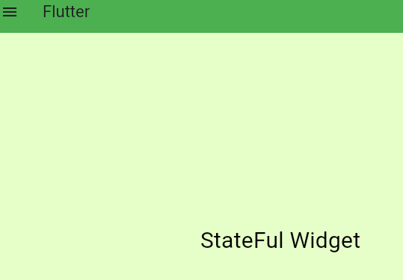

Stateless Widget:
import 'package:flutter/material.dart';

//This function triggers the build process
void main() => runApp(const MyApp());

class MyApp extends StatelessWidget {
const MyApp({Key? key}) : super(key: key);

@override
Widget build(BuildContext context) {
return MaterialApp(
debugShowCheckedModeBanner: false,
home: Scaffold(
backgroundColor: const Color.fromARGB(255, 230, 255, 201),
appBar: AppBar(
leading: const Icon(Icons.menu),
backgroundColor: Colors.green,
title: const Text(
"Flutter",
textAlign: TextAlign.start,
),
), // AppBar
body: const Center(
child: Text(
"Stateless Widget",
style: TextStyle(color: Colors.black, fontSize: 30),
),
), // Container
), // Scaffold
); // MaterialApp
}
}
Output:
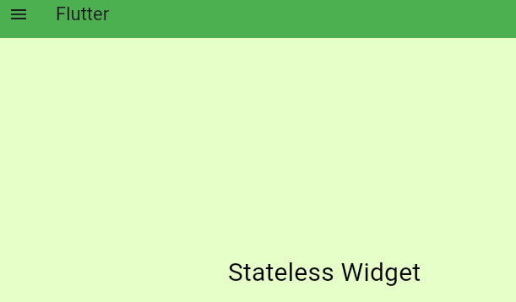
- a) Create custom widgets for specific UI elements.

import 'package:flutter/material.dart';

void main() {
runApp(const MyApp());
}

class MyApp extends StatelessWidget {
const MyApp({super.key});

@override
Widget build(BuildContext context) {
return MaterialApp(
title: 'Flutter Demo',
theme: ThemeData(

colorScheme: ColorScheme.fromSeed(seedColor: Colors.deepPurple),
useMaterial3: true,
),
home: const MyHomePage(title: 'Flutter Demo Home Page'),
);
}
}

class MyHomePage extends StatefulWidget {
const MyHomePage({super.key, required this.title});

final String title;

@override
State<MyHomePage> createState() => _MyHomePageState();
}

class _MyHomePageState extends State<MyHomePage> {

@override
Widget build(BuildContext context) {

return Scaffold(
appBar: AppBar(

backgroundColor: Theme.of(context).colorScheme.inversePrimary,

title: Text(widget.title),
),
body: Stack(

alignment: const Alignment(0.6,0.6),
children: [
const CircleAvatar(
// Ensure images/bahubali.jpg is a valid JPEG file
// and is declared in the 'assets' section of pubspec.yaml
backgroundImage: AssetImage("images/bahubali.jpg"),
radius: 100,
),
Container(
decoration: const BoxDecoration(
color: Colors.black45,
),
child: const Text(
'Rebel Star',
style: TextStyle(
fontSize: 20,
fontWeight: FontWeight.bold,
color: Colors.white,
),
),
),
],
),
);
}
}
Output:
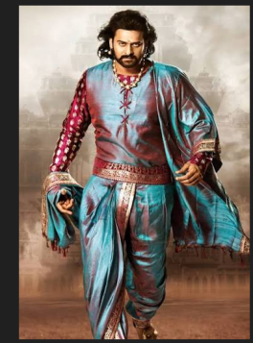Rebelstar

